Baltic Indoor Open
Time & Place 3.-5.02.2017., Ventspils Olympic Center (Sporta iela 7/9, Ventspils)
Bows: Recurve, Compound, Barebow, Traditional
Exercise: 25m Round + 18m Round + Eliminations (R,B,T – SET, C – cumulative) + MIX teams (if there is at least 4 teams, team registration is till start of qualification)
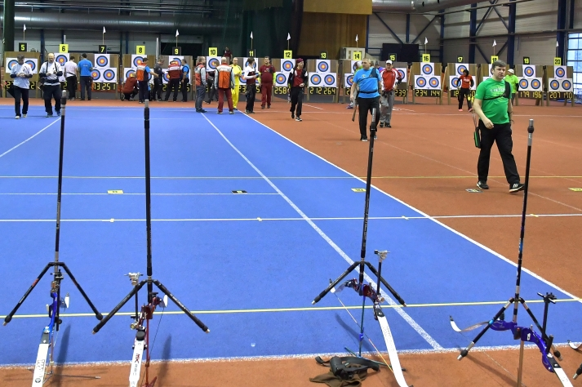
Program:
2017.02.3.
21:00-22:00 – Warm-up, registration, technical commission
2017.02.4.
8:00-9:00 – Registration, technical commission
9:00-9:15 – Opening Ceremony
9:15-9:30 – Warm-up for B & C
9:30-11:30 – 25m Round (B – full target, C – triple target)
11:30-11:45 –Warm-up for R & T
11:45-13:45 – 25m Round (R & T – full target)
13:45-14:15 – Break
14:15-16:15 – 18m Round (B – full target, C – triple target, one warm-up end)
16:15-18:15 –18m Round (R – full target, T – triple target, one warm-up end)
18:15-18:45 – Break
18:45 – Eliminations until 1/8 (one warm-up end when starting)
2017.02.5.
9:00-10:00 – Warm-up
10:00-15:00 – Individual eliminations
15:00-17:00 – Mix team eliminations
18:00 – Award ceremony
Participant fee: 20.00 euro only to LAF account LV31HABA0551037808313 (HABALV22, Swedbank, Latvijas Loka Šaušanas Federācija, Reg.Nr. LV40008026008), in notes – BACT17 name, surname, division.
Registration till 27.01.2017. in registration form.
Max participants 80 in B & C, 80 in R & T
Participants list
For more information please write to registration@archery.lv

Accommodation
Hotel OC Ventspils
Price per person 12.00 euro in double or triple rooms.
For reservations please call or e-mail hotel and use password “archery competition” (without password price will be different)
Address: Lielais prospekts 33, Ventspils
Phone. +371 636 28032
Fax: +371 636 28032
e-mail: viesnica@ocventspils.lv
web: http://www.hotelocventspils.lv

